Exercise 2: Writing Basic JUnit Tests
Scenario: You need to write basic JUnit tests for a simple Java class.
Steps:
- Create a new Java class with some methods to test.
- Write JUnit tests for these methods.
Implementation:
Calculator.java
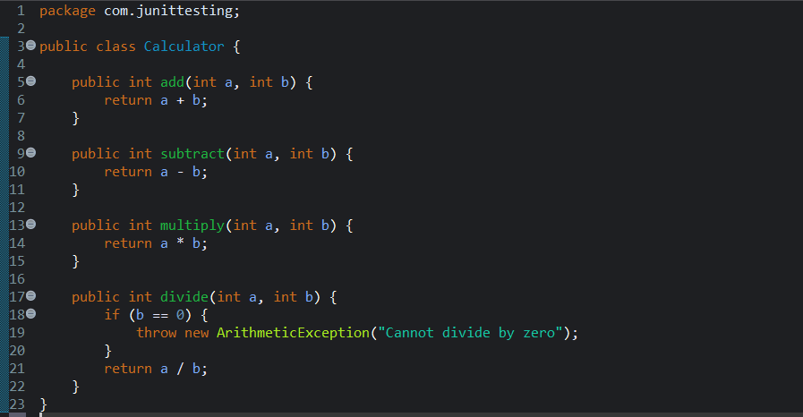

CalculatorTest.java
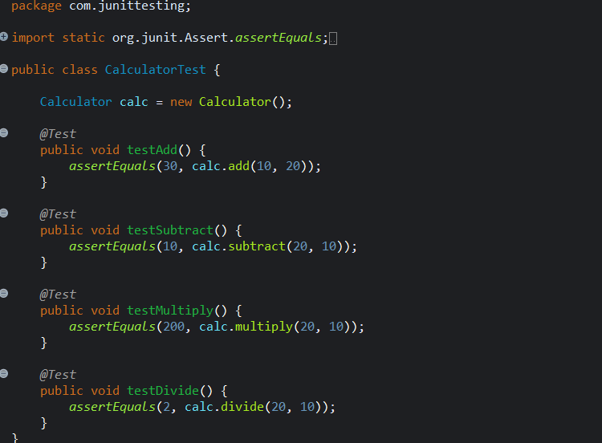

OUTPUT:
